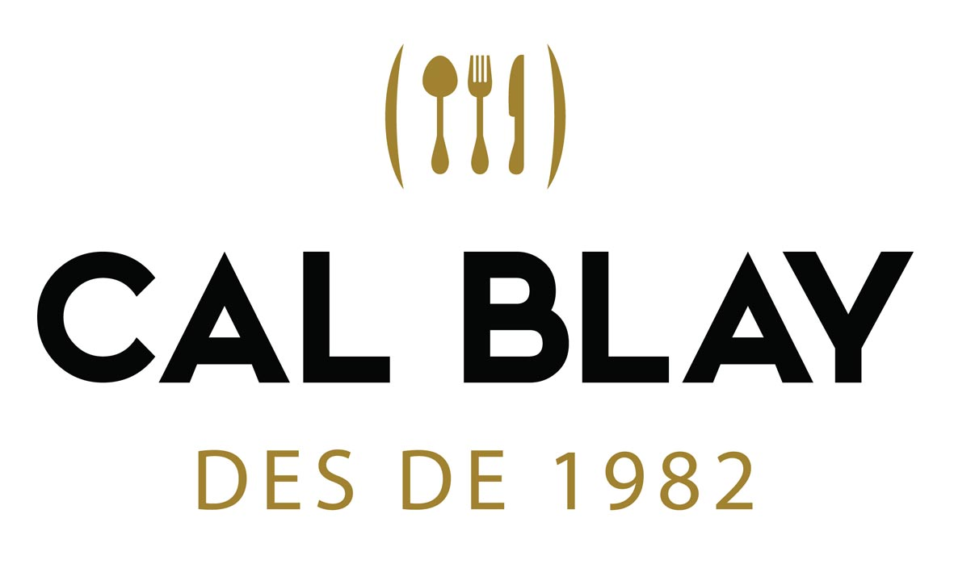
Wedding Information · 2026
THE COUPLE: JORDYN & ALEX ACT. 16/06/26

COORDINATOR: JONA
IN-HOUSE: RAQUEL
MENU: CAL BLAY 2

PACK DECO 2
WEDDING INFORMATION
Wedding day: WEDNESDAY, SEPTEMBER 2ND, 2026
CASA FÈLIX:
BV-2111, s/n, 08818 Olivella
JANE ALLEN
938 96 80 94 / 650184629
casafelix26@gmail.com
Wedding venue: CASA FELIX
Arrival time: .............................................................
Time / space ceremony: .............................................................
Time / space appetizer: .............................................................
Space for lunch or dinner: .............................................................
Space for dance: .............................................................
DJ: THE WP COORDINATES IT

TABLES |  | TOTAL | DISTRIBUTION
Round tables:
Large tables:
DECO PACK 2: The banquet can be set up with 100% round tables, or with a combination of round tables and wooden long tables, with a maximum of 50% wooden long tables. If you wish to have 100% wooden long tables, with or without table runners, a supplement of €3 per person + VAT.

GUESTS
GUESTS | MENU TastING | 1st modif. | 15 DAYS MEETING | 6 DAYS BEFORE
Adult menu
Children menu (up to 5 y.o)
Children menu (6-13 y.o)
Extra/staff menu
Baby high chairs

CEREMONY
 | Civil [ ] Religious [ ]
 | Space: |  | Arrival time: | Ceremony time:
 | Chairs for the couple (or bench depending on the venue)
 | Table for officiant + floral centerpiece
 | Decoration & flowers according to the season
 | 50 chairs included for the guests (or wooden benches in case of el Mirador de les Caves or Masia Josep Masachs)
 | Green way ........ included in: Mirador de les Caves, Masia Torreblanca, Masia Josep Masachs & Masia d’Esplugues
 | Petal way COLOUR: ....................... included in: Clos la Plana & La Torre de Can Parellada

CIVIL CEREMONY EXTRAS:
Welcome drink before the ceremony: lemonade, water and beer → Price: 3€/pax+VAT

OFFICIANT:
 | Cal Blay provide the contact to the couple |  |  | The couple’s contact

OBSERVATIONS & OTHERS FOR THE CEREMONY:
Price for basic ceremony set up: 650€ + VAT

MENU CARD + Nº TABLE + NAME CARD

COUPLE’S NAMES:
LOGO: yes [ ] (the couple has to send the logo in vectorial, illustration or HD PDF)
nO [ ]
LANGUAGE (appetizer max. 1):
LANGUAGE (banquet max. 2):

MENU CARD for the banquet
 | PACKS | MODEL | NAME | PAPER
 | 1, 2, 3 | Nº. 1 | VINEYARD | Kraft
 | 1, 2, 3 | Nº. 2 | WATERCOLOR FLOWERS | Beige
 | 1, 2, 3 | Nº. 3 | OLIVE TREE | Beige
 | 1, 2, 3 | Nº. 4 | EUCALYPTUS | White
 | 2, 3 | Nº. 5 | GREEN FLOWERS | Beige
 | 2, 3 | Nº. 6 | ELEGANT | Beige
 | 2, 3 | Nº. 7 | ILLUSTRATIONS | Beige
 | 2, 3 | Nº. 8 | LEMONS | White
 | 3 | Nº. 9 | MINIMAL | White
 | 3 | Nº. 10 | DRAWING | Beige
 | 3 | Nº. 11 | STRIPS | Beige
 | 3 | Nº. 12 | COLORFUL FLOWERS | White
NAME CARD
YES
NO
Nº TABLES FOR THE BANQUET
STANDARD TABLE NUMBER (same model than menu card) / Options:
[ ] Log support included
[ ] Golden frame - supplement PACK 1: +3€/table - PACK 2: +3€/table - PACK 3: +2€/table
[ ] Golden mirror – supplement PACK 1: +4€/table - PACK 2: +4€/table - PACK 3: +2€/table
[ ] Golden structure – supplement PACK 1: +2€/table - PACK 2: +1€/table - PACK 3: included
PERSONALIZED TABLE NUMBER / Options:
[ ] The couple prints it and Cal Blay provides the support (log) / Nota: trunk support included without any cost
[ ] The couple sends the design and Cal Blay prints it / Supplement 3€/table + trunk support included without any cost
[ ] The couple sends the design and Cal Blay prints it / Supplement 3€/table + frame /mirror/structure – consult the supplement depending on the pack

TABLES DISTRIBUTION & LISTS OF GUESTS
Provided by Cal Blay
Provided by the couple

SEATING STRUCTURE
Cal Blay venues: Provided by Cal Blay
[ ] Bookshelf → MC – TCP – JM – CLP - ME
[ ] Boho bottles→ Price: 150 € + VAT (Transport included in Cal Blay venues)
[ ] “Our favorite persons” → Price: 200€ + VAT (Transport included in Cal Blay venues)
Other venues:
[ ] Provided by Cal Blay – wooden structure included
[ ] Provided by the couple
[ ] Boho bottles→ Price: 150 € + VAT (Transport not included: 150€ + VAT)
[ ] “Our favorite persons” → Price: 200€ + VAT (Transport not included: 150€ + VAT)

table decorations / floral centerpieces
 | ............ round tables |  |  | ............ large tables

Nº 1: Aromatic
Included: Pack 1 – Pack 2 – Pack 3
Nº 2: Candle cylinders
Included: Pack 1 – Pack 2 – Pack 3
Nº 3: Paniculata
Included: Pack 1 – Pack 2 – Pack 3
Nº 4: Calla
Included: Pack 1 – Pack 2 – Pack 3
Nº 5: Boho
Included: Pack 1 (with 10€ supplement) – Pack 2 – Pack 3
Nº 6: Paniculata candle cylinders
Included: Pack 1 (with 10€ supplement) – Pack 2 - Pack 3
Option to add transparent [ ] or gold [ ] chandelier to this center at: €5/ chandelier
Nº 7: Vases with colored carnations
Included: Pack 1 (with 10€ supplement) / Pack 2 included / Pack 3 included
Option to add transparent [ ] or gold [ ] chandelier to this center at: €5/ chandelier
Nº 8: Oranges and lemons
Included: Pack 1 (with 10€ supplement) / Pack 2 – included / Pack 3 – included
Nº 9: Lilium
Included: Pack 1 (with 10€ supplement) / Pack 2 (with 10€ supplement) / Pack 3 – included
Nº 10: Vase with assorted flowers
Included: Pack 1 (with 20€ supplement) / Pack 2 (with 10€ supplement) / Pack 3 – included
Option to add transparent [ ] or gold [ ] chandelier to this center at: €5/ chandelier
Nº 11: Anturium
Included: Pack 1 (with 20€ supplement) / Pack 2 (with 10€ supplement) / Pack 3 – included
Option to add transparent [ ] or gold [ ] chandelier to this center at: €5/ chandelier
Nº 12: Cup
Included: Pack 1 (with 20€ supplement) / Pack 2 (with 15€ supplement) / Pack 3 – included
Option to add transparent [ ] or gold [ ] chandelier to this center at: €5/ chandelier

OBSERVATIONS AND OTHER TABLE DECORATIONS
Supplements are for tables, including round tables (8-12 pax) and large tables (6 pax).

TABLEWARE
TRADITIONAL MENU - BANQUET
Round tables with tablecloth: nature [ ] stone [ ] white [ ] / others to be consulted
Large wooden tables (0,84 x 1,83) with tablecloth way: nature [ ] stone [ ]
White napkin ( included )
Cutlery CB
Glassware CB

OPTIONAL
Imperial table (1,20 x 1,83) with tablecloth white [ ] black [ ] beige [ ] stone [ ] → Suppl. 5€/person
Round tables with tablecloths rental GREEN, PINK → Supp. €25 / tablecloth
Optional napkin [ ] floral [ ] green [ ] yellow → Supp. 1,00€/napkin
Optional: gold-plated cutlery →Supp. 1€ / cutlery [1-course menu 4€ / 2-course menu 6€]

VASE/CUPS OF WATER
 | MODEL | PACK 2
 | Transparent vase diamond | Included
 | Green vase | Included
 | Belem cup | Included
 | Mix color cups | 1€ supplement

UNDER PLATE
 | MODEL | PACK 2
 | Vienna Ratan | Included
 | Vimet | Included
 | Green | Included
 | Golden Sun | Included
 | Golden | 1€ supplement
 | Transparent | 3€ supplement
 | Pink glass | 3€ supplement
CHAIRS
Chiavari (Tiffany) white - Pack 1 (with supplement of 10€) / Pack 2 (included) / Pack 3 (included)
(included in: Mirador de les Caves / Masia Torreblanca / Josep Masachs) further than 40 km transport not included
Crossback -Pack 1 (with supplement of 10€) / Pack 2 (included) / Pack 3 (included)
(included in: Clos la Plana / La Torre de Can Parellada / Parc Samà / Font de la Canya) further than 40 km transport not included
Vela exclusive Masia Esplugues
Bambú - Pack 1 (with supplement of 10€) / Pack 2 (supplement of 8€) / Pack 3 (supplement of 6€)
further than 40 km transport not included
White chair + cushion grey

OBSERVATIONS TABLEWARE / FURNITURE

WAITERS UNIFORM
Beige short apron + beige braces
Long black apron + black tie
Brown apron + white shirt

GASTRONOMY
Nºpax | Special menus |  |  | Late night snacks
 | Gluten free |  |  | Mini sandwiches
 | Vegetarians / vegans 100% |  |  | Fresh fruit
 | Lactose intolerant |  |  | Candy Bar → Price: 2,50€/pax (minimum 70 pax)
 | Seafood allergic |  |  | Nutella mini croissants i cream xuxos → Price 3€/pax
 | Nuts allergic |  |  | Fried eggs → Price: 4€/pax (minimum 100 pax)
 | No meat / ok fish |  |  | Mini McBlays → Price: 3,80€/pax
 |  |  |  | American buffet: hot dogs + McBlays + fries → Price: 6,50€/ pax (minimum 100 pax)
 |  |  |  | Entrepans en ruta: Mini MCBlays, Pizza Formatge i entrepà de Pulled Pork → Preu: 5,50€/pax

OBSERVATIONS ALLERGIES / INTOLERANCES
Please inform us of any food allergies or intolerances as soon as possible (at least 15 days before the celebration), for a correct preparation and coordination with our suppliers and chefs. Otherwise, we will not be able to guarantee this service.
Appetizer for children
For celebrations with more than 5-6 children, we inform you about the option of an appetizer only for them:
Mediterranean chips
Olives
Fuet
Manchego cheese
Homemade croquettes

Price: 10€/child + VAT.
We will set up a table just for them during the aperitif, they will be served and so their parents will also have more control over them.
From previous experience, this is an option that works very well when there are more than 5-6 children, especially when there is no lack of food from the snacks provided for the adults (snacks, appetizers and buffets).
Cal Blay always carries the correct grammage of food for the expected number of adults, but when there are more than 6 children, we can't take the risk of missing food from the adults.
Note: it is only a recommendation so that everyone is satisfied during the appetizer and to ensure a good service.

CHILDREN’S / TEENAGER’S MENU
Combo dish | Macaroni Bolognese + chicken sticks + fries + ketchup
Dessert | Ice cream

WEDDING CAKE ITALIAN-STYLE WEDDING CAKE (1 flavour – cream)
 | NO |  |  | No
 | YES, with trolley |  |  | Yes → Price: 250€+VAT  Included: red fruit toppings, blackberries, raspberries, chocolate, ...
 | YES, inside the dessert buffet

DESSERTT BUFFET CAVA PYRAMID
 | NO |  |  | NO
 | YES, served by the couple |  |  | YES → Price: 250€ + VAT
 | YES, but NOT served by the couple |  |  | YES → Price: 250€ + VAT

GASTRONOMY OBSERVATIONS

PHOTOS OF CHAMPAGNE PYRAMID & WEDDING CAKE
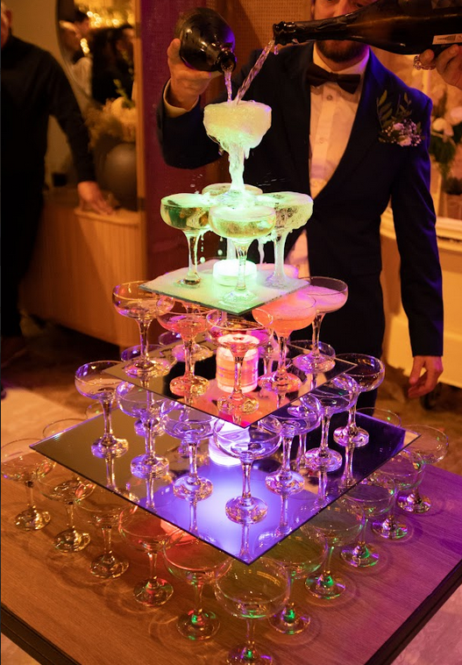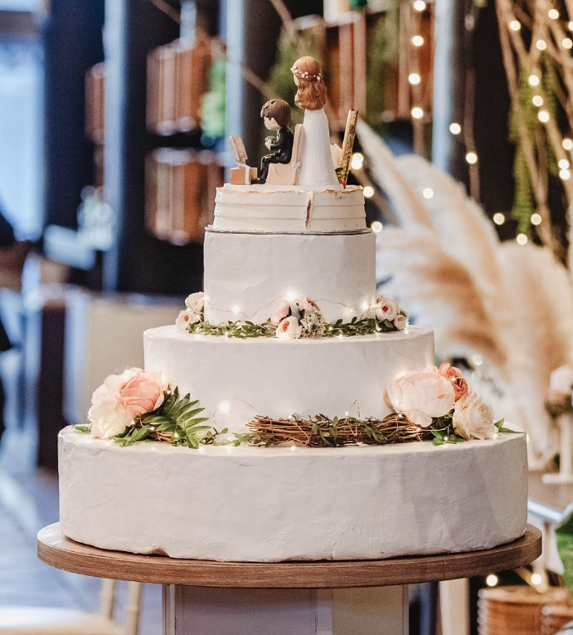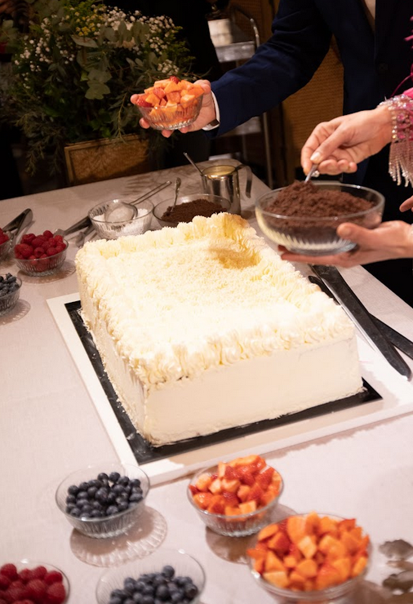

CELLAR
White wine | Oliver viticultors 10.000 hores Floral ECO D.O. Penedès
Red wine | Legaris Roble Tinto Fino D.O. Ribera del Duero
Sparkling wine | Raventós i Blanc Blanc de Blancs Escumosos de la Conca del Riu Anoia

LIQUOR AND DRINKS BAR FOR THE PARTY
Liquors for coffees
Special liquors for coffees:
Drinks bar for the party
Duration of drinks bar for the party: |  | (duration according to accepted proposal)
Special liquors for the party:

Special buffets for party drinks bar |  | Price
“Mojitos” |  | Free of charge, Courtesy of Cal Blay
Various Cocktails |  | Free of charge, Courtesy of Cal Blay

Extra hour for party drinks bar:
 | YES |  |  | NO |  | Price: | 500€/hour + VAT | (to be decided at the last moment)

Observations liquors and drinks bar
If you contract an extra hour for party drinks bar there are a charge of 100€ + VAT for the rental fee in Josep Masachs, apart from the price per extra hour for extending the drinks bar.

BUSES DEPARTURES
TIME | DESTINATION

CONTACT EXTERNAL PROVIDORS
EXTERNAL PROVIDOR | CONTACT (NOME + PHONE/EMAIL) | @ INSTAGRAM

OTHERS / DECORATIONS EXTRAS
x | ECO CORNER | Cal Blay
 | Deco Assistant | Price: 120€ + IVA
 | Find your message  (included in Cal Blay venues) | Included: string, clips and message placement  Not included: the notes with the messages
 | Corner of our lives  (included in Cal Blay venues) | Included: table/shelf, poster and decoration  Not included: 15/20 photos + details
 | Leave us a note  (included in Cal Blay venues) | Included: table, poster and decoration  Not included: signature book and pens
 | Baskets with rice and petals (choose an option)  *For approximately 50 guests | 50% petals + 50% rice → price: 100€ + VAT  100% petals → price: 130€ + VAT  50% petals + 50% olive leaf → price: 140€ + VAT  100% olive leaf → price: 150€ + VAT
 | Scale with 50 cones (choose an option) | 50% petals + 50% rice → price: 120€  100% petals → price: 150€  50% petals + 50% olive leaf → price: 160€  100% olive leaf → price: 170€
 | Structure + neon phrase without Chester sofa  [ ] Boig per tu  [ ] Better together  [ ] Love is in the air | Price: 250€ + VAT
 | Structure + neon phrase with Chester sofa  [ ] Boig per tu  [ ] Better together  [ ] Love is in the air | Price: 450€ + VAT
 | Welcome bicycle with floral decoration | Price: 180€ + VAT
 | Welcome bicycle without floral decoration | Price: 100€ + VAT
 | Glitter Bar | Price: 200€ + VAT
 | Extra decoration for presidential table | Price: 60€ + VAT
 | “No hay boda sin beso” (structure) | Ceremony without sign → Price: 250€ + VAT  Ceremony without sign + corner with sign and changing location → Price: 300€ + VAT
 | Boho mountain (structure) | Price: 250€ + VAT
 | Ratan Emmanuelle chairs | Two chairs without flowers → Price: 80€ + VAT  Two chairs with flowers → Price: 140€ + VAT
 | Light box:  “Que el fin del mundo nos pille bailando” | Price: 150€ + VAT
 | Phrases in wooden structures  [ ] Hoy dos familias se convierten en una  [ ] All you need is Love  [ ] Tota aventura comença amb un sí | Price unit: 40€ + VAT  Price 3 phrases: 100€ + VAT
 | Polaroids | Price: 200€ + VAT (service 2 hours + coordinator)  Photo reel (20 photos) → Price: 25€ + VAT
 | Personalized decoration for Clos la Plana's swimming pool | Price: 300€ + VAT
 | Personalized decoration for Josep Masachs's swimming pool | Price: 250€ + VAT
 | Personalized decoration for TCP’s lake | Price: 200€ + VAT
DETAILS FOR GUESTS

INTERNAL NOTES MAÎTRE
WELCOME

CEREMONY

APPETIZER

BANQUET

PARTY

LAST MEETING – 15 DAYS

SURPRISES - Gifts
1.
2.
3.
4.
5.

additional information
The revised menu price is guaranteed for a minimum of 70 adult menus.
Price variations according to the number of adult menus:
For less than 70 adult menus +6€.
For less than 50 adult menus please ask for supplement* The supplement will be counted for the total number of adult menus, and from adult nº. 1
CONFIRMATION OF FINAL NUMBER OF GUESTS: Deadline to send LIST OF TABLES, LIST OF OBSERVATIONS, DISTRIBUTION OF TABLES… is from Friday X to Sunday X (the weekend before the wedding).
Monday X morning we will close the project and the final numbers of guests. WE WILL NOT ACCEPT GUEST CANCELLATIONS FROM MONDAY AT 12 NOON.
LAST MEETING 3/4 WEEKS BEFORE THE WEDDING:

